MODULE – 4 INTRODUCTION TO DBMS

LAB EXERCISES

17. SQL View
Lab 1.
Create a view to show only the title, author and price of the books from the books table.
Ans.
1. CREATE VIEW book_view AS SELECT title, author, price FROM books;
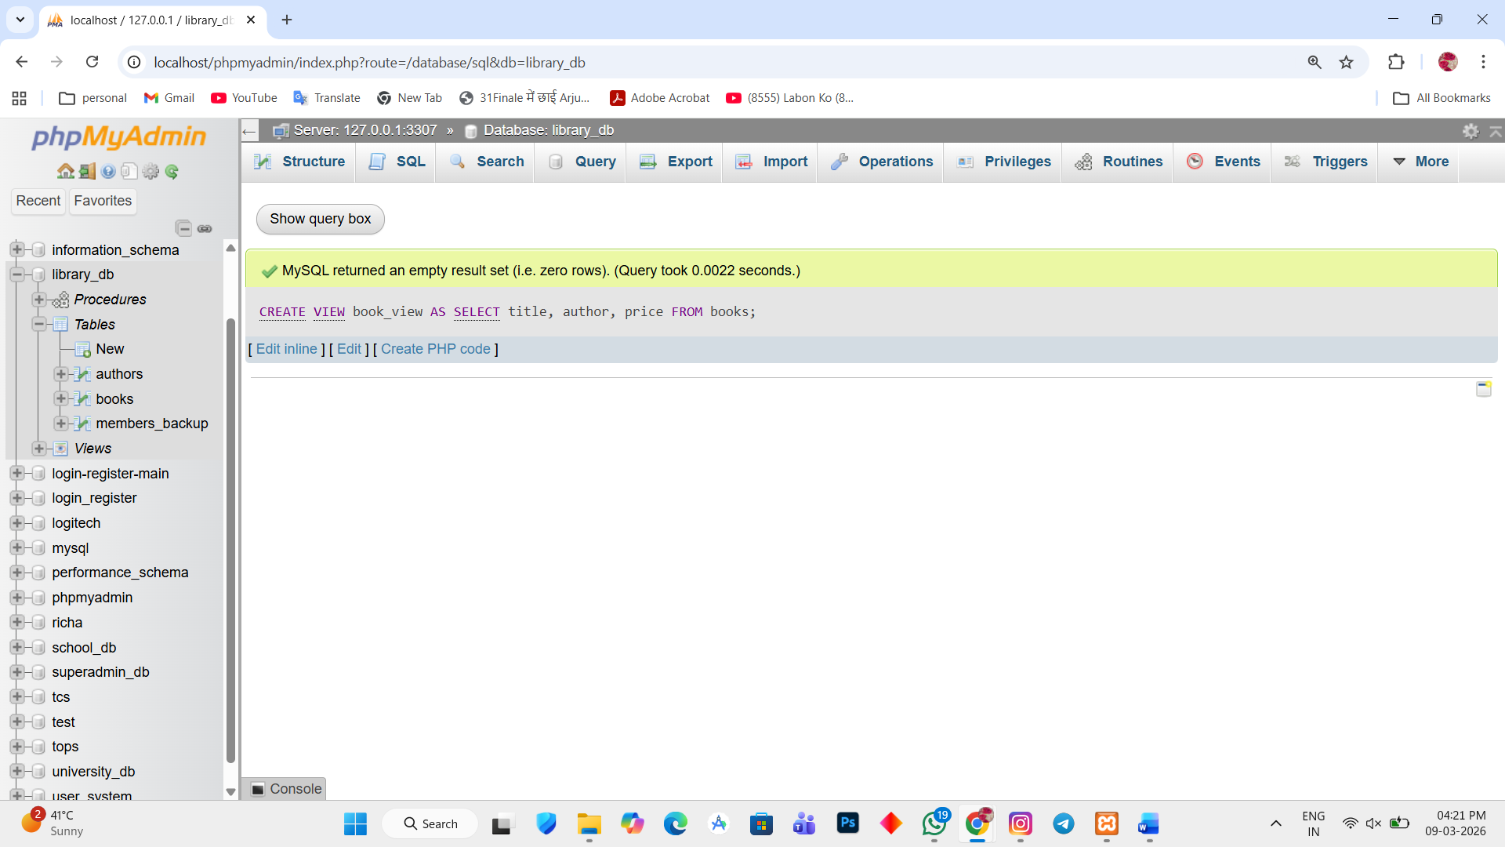

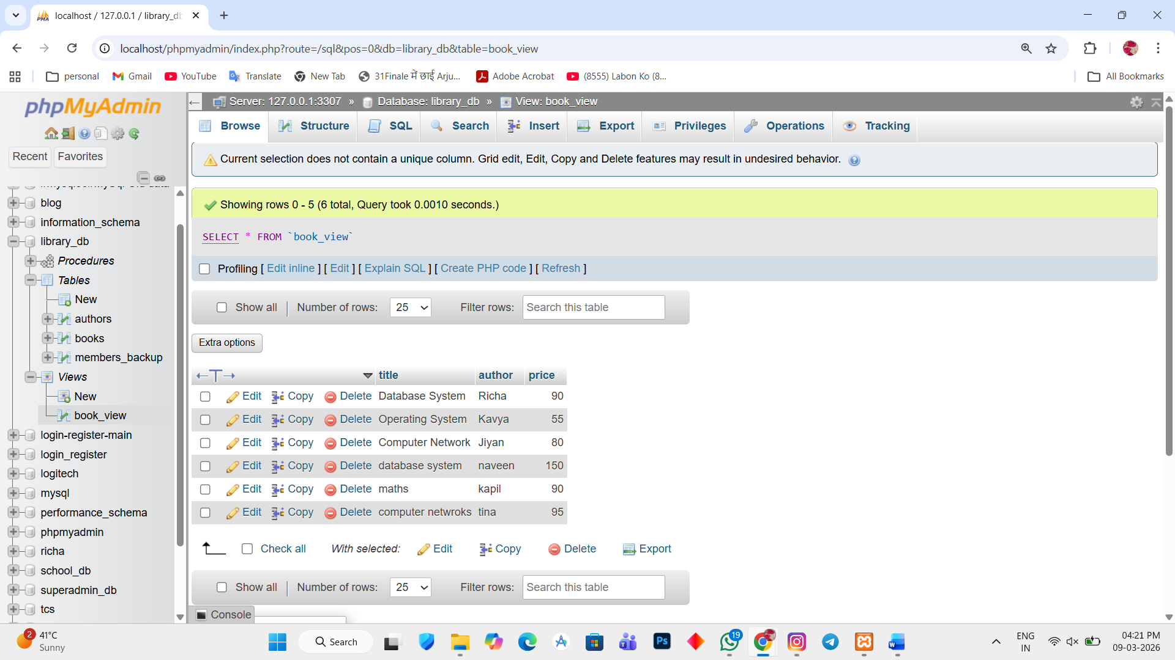

Lab 2.
Create a view to display members who joined before 2020.
Ans.
1. CREATE VIEW members_before_2020 AS SELECT * FROM members_backup WHERE date_of_membership < '2020-01-01';
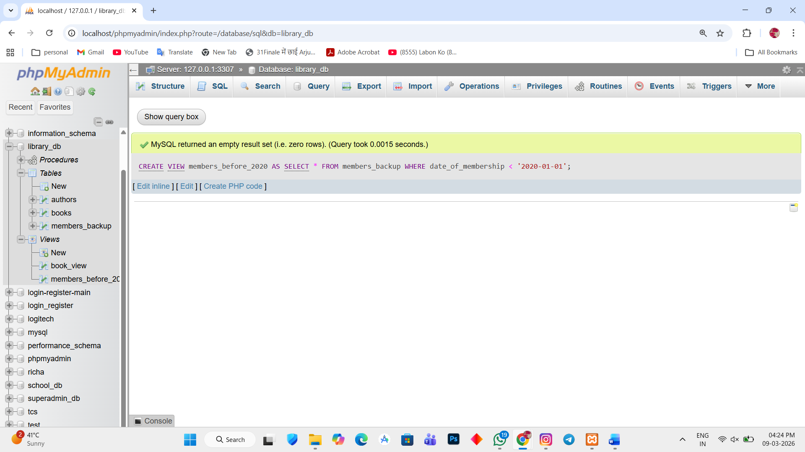

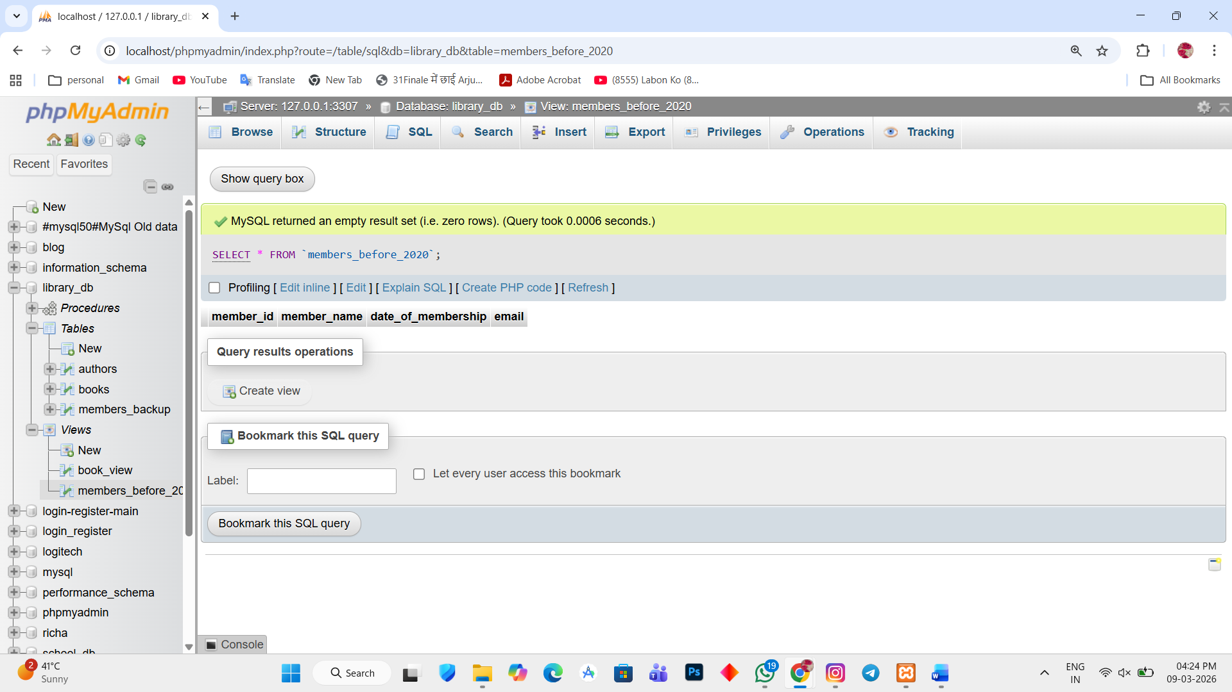

2. CREATE VIEW members_before_2023 AS SELECT * FROM members_backup WHERE date_of_membership < '2023-01-01';

